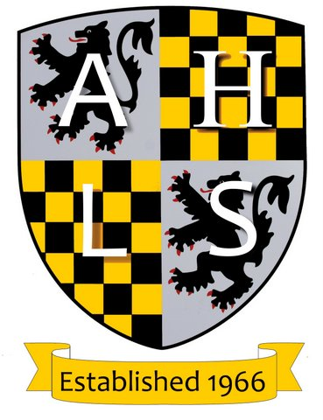
Alresford Historical &
Literary Society
NEWSLETTER - 1st April 2024
Next meeting, 7:30pm Wed 17th April - The Methodist Church - AGM & Talk
The Society’s News and Plans
In partnership with New Alresford Town Council, and funded by our Arthur Stowell charitable fund, your society has commissioned a “timeline” for Sun Hill Junior School’s playground to be erected in April. This is a 20 metre long (!) durable display of major world events. It aims to add historical context to topics raised by current history curricula.
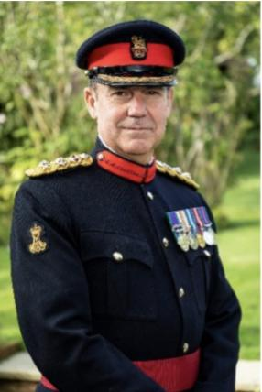
At our AGM the reports sent to you last month will be briefly presented by members of the committee. Concerning the latter, after the sad deaths of committee members Brian Tippett and John Miller we need a committee member with an academic historical and/or literary background. Any member feeling able to fill this gap, please let us know.
Rose, Crown and Castle – Hampshire & IoW’s Citizen Soldiers
a talk by Patrick Crowley (following our brief AGM)
Our speaker will tell the story of Hampshire and the Isle of Wight’s citizen soldiers who acted patriotically through times of war and peace. His recently published book celebrates their 500 years of history from the militia, yeomanry and volunteers, through to the Territorial Army and today’s Army Reserve.
Patrick Crowley, a deputy colonel of the Princess of Wales’s Royal Regiment, is currently the chief executive of the South East Reserve Forces & Cadets Association, an arms-length body which supports the interest of reserves and cadets in the south east. He is author of 8 books on military history and lives in Hampshire. Patrick Crowley
Praise for our last talk on 20th March: The Porthole Murder by Paul Stickler

Paul led us through a forensic account of Gay Gibson’s disappearance and James Camb’s murder conviction - a fascinating story well told! But this appreciation doesn’t do justice to what became a gloriously satisfying evening! Paul is a perfect speaker: always accurate but speaking without notes, keeping our audience (of 76) engaged, pausing to let ideas sink in and spicing his analysis with wry humour. He left us sitting in judgement as if on the jury at James Camb’s 1947 trial in Winchester’s Great Hall. A very good evening indeed! [MD]

Background: Paul joined Hampshire Constabulary in 1978 and spent the majority of his time investigating murders for the CID. He was seconded to the FBI Academy at Quantico to study international perspectives of crime investigation. Since his retirement in 2008 he has indulged his passion for history, researching murders in the first half of the twentieth century. His talks and publications are widely appreciated and much praised. Paul Stickler
Best wishes from
Mike Dickens, Hon Secretary secretary@alresfordhistandlit.co.uk

