Issue No.21 - 1996

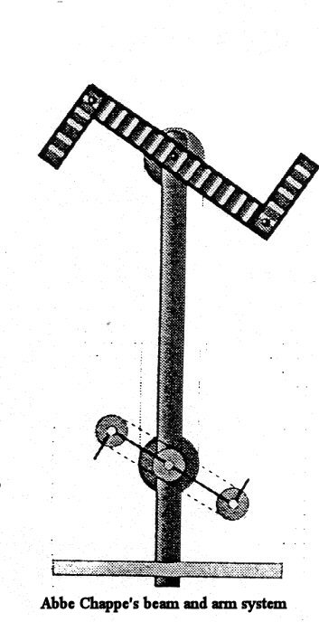
The French Telegraphe!
If you'll only just promise you'll none of you laugh
I'll be after explaining the French Telegraphe!
A machine that's endowed with such wonderful pow'r
It writes, reads and sends news 50 miles in an hour.
Then there's watchwords, a spy-glass, an index on hand
And many things more none of us understand,
But which, like the nose on your face, will be clear
When we have as usual improved on them here.
Adieu, penny posts! mails and coaches, adieu!
Your Occupation's gone, 'tis all over wid you.
In your place telegraphs on our houses we'll see
To tell time, conduct lightning, dry shirts and send news.
from the play Great News,
or a Trip to the
Antipodes,
by Charles Dibden.
First produced in London
on 11th October 1794.

