Gates at Arlebury Park.
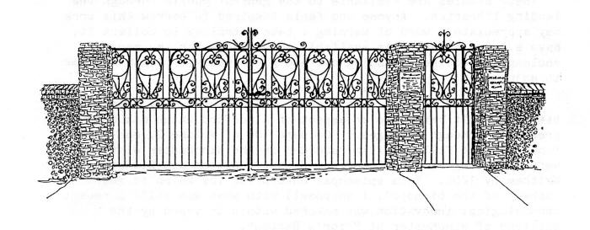
These handsome wrought iron gated were erected at the entrance to Arlebury Park Club and grounds in memory of Geoffrey Searles 1897-1979 who represented Alresford on the Winchester City Council for many years.
He was a Veterinary Surgeon with a practice in the town first in West Street in 1927 later in New Farm Road and was a partner in a practice at Four Marks. He had also served as a volunteer fireman.
The quality of the work on these gates cannot be appreciated by the public as they are kept open all the time to allow easy access to Arlebury Park Club but they are a permanent memorial to a man who carried out his civic duties with integrity.

